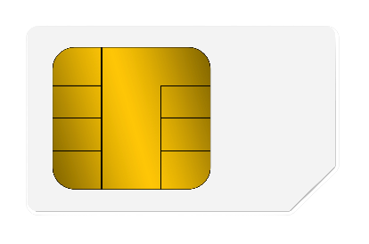

debit

5412 7512 3412 3456

12/23

Lee M. Card

Platinum